【土木構造・材料論文集 第33号 2017年12月】

**A survey on existing China timber arch bridges**

Yan Yang1, Shozo Nakamura2*, Baochun Chen3, Takafumi Nishikawa4

1 College of Civil Eng., Fuzhou University, Fuzhou, China, 350108

2 Dept. of Civil and Environmental Eng., Nagasaki University, Nagasaki, Japan, 852-8521

3 College of Civil Eng., Fuzhou University, Fuzhou, China, 350108

4 Dept. of Civil and Environmental Eng., Nagasaki University, Nagasaki, Japan, 852-8521

*Corresponding Author, E-mail: kabse@jsce.ac.jp

　The history of China timber arch bridge construction is reviewed briefly in this paper. All the existing China timber arch bridges are investigated by field survey from the view of bridge engineering. Then their major structural parameters are analyzed with respect to length, width, span, and the rise-to-span ratio, *etc*. It is shown that there are 128 timber arch bridges in service in China, most of which are single span bridges, accounting for 95.3%. For the single span bridges, the longest span is 37.6m; the span is typically between 20m-40m; the bridge length is usually between 20m-50m; the width is mainly between 4m-5m; and the rise-to-span ratio is from 1/4 to 1/7. For the 6 multi-span bridges, there is one bridge with six spans, two bridges with three spans and three bridges with two spans.

*Key Words*: *timber arch bridge, rise-to-span ratio, diameters of arch ribs, use Italic for key words*

**1. Introduction**

Timber arch bridges have been built in many countries. China timber arch bridges have attracted particular attention because of its special structure forms and cultural value, and attracted great research interests in recent years. Its research and protection are hot topics in the fields of ancient bridges and cultural heritage.

Many researches have been carried out by cultural relics workers and architects in China, focusing on the construction history, aesthetics, social function, cultural value and so on. However, there are still many problems have not been studied in the field of research on the China timber arch bridges. Firstly, a complete database of the China timber arch bridge has not been created untill now. A few bridges have often been missed, mistaken or repeatly counted in the literature. One reason is that the China timber arch brige is somewhat similar to the cantilever bridge and the strut-frame bridge in appearance. Secondly, the research works from the view of structural engineering and bridge engineering are insufficient. Researches on the major structure, the FE analysis, and the structural parametric analysis are very rare. This is partly because bridge engineers are busy in building new bridges or focusing on the maintenance of highway and railway bridges, and few of them have time and interests to study the ancient bridges in China.

China timber arch bridges are all constructed with the traditional construction technology, depending on the experiences handed down from generation to generation. However, very few timber arch bridge craftworkers are still alive today with old ages, and few young people like to learn this skill. Furthermore, many ancient timber arch bridges are in poor conditions and need maintenance and strengthening.

Reflecting such circumstances, the traditional construction technology of China timber arch bridges was listed in the Urgent Safeguarding List of Intangible Cultural Heritage by UNESCO in 20091,2). More and more people suggest the China should declare the timber arch bridges as the world cultural heritage today. It is very important to gather detailed and accurate information of China timber arch bridge for declaring world heritage.

In this article, an investigation on the current situations of the bridges, the main arch ring structures including the longitudinal two systems and the cross-section, the major structureal parameters such as the length, span as well as the rise-to-span ratio is carried out by field survey. Then the main structureal parameters have been analyzed from the view of bridge engineering, aiming at providing references for further studying, designing and constructing of China timber arch bridges as well as inspiring to use the structure in bridge engineering and structural engineering in the future.

**2. Overview of the development and present situation of China timber arch bridges**

**2.1 Development history**

According to historical records, the first timber arch bridge was built from 1032 to 10333) in the Song Dynasty (960-1279). Thereafter, many this type of bridges had been built over the Fen and Bian Rivers in central and north areas of China. The local people had great benefit by these bridges, and called them Rainbow Bridges due to their arch shape. As time passed by, the Rainbow Bridges vanished due to war, fire, winds, floods and decay of wood. At the same time, the old capital was moved to the new place, Lin’an (Today, Hangzhou, Zhenjiang Province) after the Song Dynasty had been overthrown, and fewer and fewer and at last

no one such bridge were built in the region where many rainbow bridges exsisted in Song Dynasty. Therefore, no Rainbow Bridges survived and it was believed the technology of this kind bridge had been lost because no details of their design and construction technology have been recorded in the literature. In 1950s, some bridge engineers found that the bridge in the famous painting of “Chhing-Ming Shang Ho Thu” (Festival of Pure Brightness on the River, shown in Fig.1.) was a Rainbow Bridge,. Because the bridge spans the Bian river, it is called as Bianhe Rainbow Bridge, in which the Bianhe is the literal translations from the Bian river.

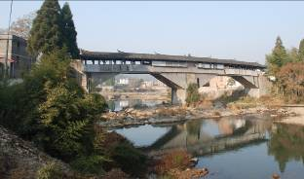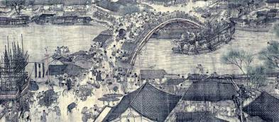 (a) The Beijian Bridge (b) The Qiancheng Bridge

Fig.1: The Rainbow Bridge in Chhing-Ming Shang Ho Thu2) (single span) (multi-span)

Fig.2: Existing Min-zhe Timber arch bridges



Number of bridges



< 5

5 ~ 10

> 10

1-Fuzhou, 2-Minhou, 3-Minqing, 4-Gutian, 5-Xiapu, 6-Fu’an, 7-Zhouning, 8-Pingnan, 9-Jian’ou, 10-Shunchang, 11-Fuding, 12-Zherong, 13-Shouning, 14-Zhenghe

15-Taishun, 16-Qingyuan, 17-Jingning, 18-Qingtian, 19-Longquan

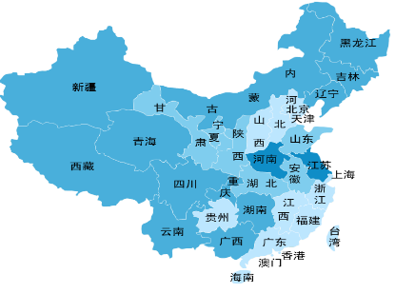

Zhejiang province

**1**

**3**

**7**

**5**

**4**

**19**

**18**

**12**

**10**

**9**

**16**

**17**

**14**

**15**

Border of Fujian and Zhejiang province

Fujian province

**2**

**6**

**13**

**11**

**8**

Fig.3: Distribution map of China timber arch bridges

The structure of this bridge was clear in the picrture regarded as only one historical recorder for the structure of Biahe Rainbow Bridge.

In 1970’s many similar bridges were found in Fujian Province and Zhejiang Province by cultural relics workers4)~6). Because they are all located in the Fujian and Zhejiagn Provinces, and their structural form is somewhat different from the Bianhe Rainbow Bridge, they are called as Min-zhe timber arch bridges, in which the “Min” and “Zhe” are the short names of Fujian Province and Zhejiang Province, respectively.

There is no historical record showing accurately when the first Min-zhe timber arch bridge was built. The Min-zhe timber arch bridges in service today were constructed or rebuilt in different Dynasties since the Song Dynasty, which will be described in Section 2.2.

Therefore, the China timber arch bridge has two branches in fact, one is the ancient but un-extant Bianhe Rainbow Bridge as shown in Fig. 1, the other is the existing Min-zhe timber arch bridge as shown in Fig.2. The most distinct difference between these two types of bridges is whether it has covering houses or not in appearance. Since no ancient Bianhe Rainbow bridge has survived today, this research focuses on the existing Min-zhe timber arch bridge.

**2.2 Present situation**

Based on the collected mass infromation of China timber arch bridges, a survey on the briges has been carried out by the authors since 2008. The survey shows more than one hundred Min-zhe timber arch bridges have been destroyed since 1949. Some bridges had been destoried by fire, winds and floods, etc.; some bridges had been replaced by new bridges for the sake of economic development; especially, rebuild the road and build of new hydropower station.

There are 128 Min-zhe timber arch bridges in service today1),7)~12). All of them are located in mountainous areas in northeast Fujian Province and southeast Zhejiang Province, as shown in Fig.3. There are 83 in Fujian Province, over half of the total. Over 10 bridges are in each of the Shouning and Pingnan Counties of Fujian Province, and the Taishun, Jinning and the Qingyuan Counties of Zhejiang Province. The Shouning County has marvelously 19 bridges, accounting for 14.8% of the total1). The distribution of the bridges is listed in Table. 1.

Table 1: Number of timber arch bridges in China

|  |  |  |  |  |  |
| --- | --- | --- | --- | --- | --- |
| Province | County | Total | On preservation list | | |
| National Level | Provincial Level | County ‘s Level |
| Fujian  (83) | Shouning | 19 | 6 | 1 | 12 |
| Pingnan | 15 | 3 | 2 | 8 |
| Zhouning | 9 |  | 1 | 1 |
| Gutian | 6 | 1 |  | 4 |
| Fu’an | 5 |  |  | 1 |
| Zherong | 2 | 1 | 1 |  |
| Fuding | 1 |  |  | 1 |
| Xiapu | 1 |  |  | 1 |
| Fuzhou | 1 |  |  | 1 |
| Minhou | 7 |  |  | 7 |
| Minqing | 2 |  |  | 1 |
| Zhenghe | 7 |  |  | 2 |
| Jian’ou | 5 |  |  |  |
| Shunchang | 3 |  |  |  |
| Zhejiang  (45) | Taishun | 11 | 6 |  |  |
| Qingyuan | 15 | 1 | 1 | 4 |
| Jingning | 15 |  | 2 | 6 |
| Longquan | 2 |  | 1 |  |
| Qingtian | 2 |  |  |  |

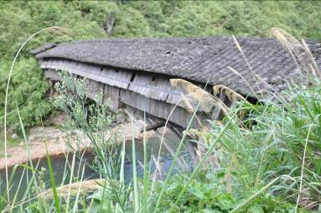 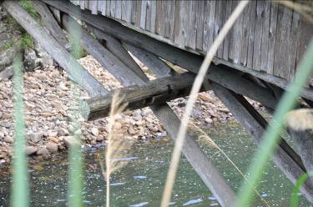

Fig.4: Construction time Fig.5: A timber arch bridge in danger

It is quite common for a bridge to be dated in China. The earliest construction time, periodic maintenance time and the last rebuilt time often been recorded in the genealogies, county annals, and bridge plaques, steles and covering houses. According to historical record in this survey, it is found that many timber arch bridges were built from the Ming Dynasty (1368-1644) to 1960s. No timber arch bridges were built during 1966 and 2000 due to scarcity of timber resources and the development of the other bridge types, etc.. However, 14 bridges were built after 2000, because more and more people have recognized the technology and culture value of the China timber arch bridge. The time distribution of the last rebuilding of the existing timber arch bridges is shown in Fig. 4. It can be seen that 53.9% of the existing Min-zhe timber arch bridges were built in Qing Dynasty. It should be pointed out that the “rebuilt” here does not include maintenance, repair and relocation which does not change the structure form 1).

Most of these timber arch bridges are footbridges located in ancient pedestrian paths or in ancient villages. They serve not only for traffic, but also for communications, trade, etc. As an important part of the precious cultural heritage handed down from the ancient China, they represent the essence of traditional architecture of China. They all reflect the social and architectural characteristics of the time of construction. Among 128 timber arch bridges, 18 timber arch bridges have been listed in the national preservation list of cultural relics, 9 in the provincial preservation list, and 49 in the county’s preservation list. The specific locations are shown in Table 1. We can find that, the Pingnan County and Shouning County have the most number of them.

Generally, these bridges on the list have better condition than the bridges unlisted. However, our survey revealed that some of the listed bridges are still in poor condition, even in a unsafe situation as one in Fig.5 due to lack of maintenance. It is imperative to maintain or strengthen these bridges.

**3. Tree species used for the bridges**



Covering house

Fig.6:Sketch of Min-zhe timber arch bridge1)

 

(a) (b)

Fig.7: Plane sketch of Main arch 11)

Fujian and Zhejiang mountain area is rich in Chinese fir. This kind of wood grows faster, is easy to process and not easy to be decayed and eaten by moth. Its mechanical performance is more stable than other kinds of woods. Consequently, this kind of wood has been the first choice by craftworkers. The investagation results show that almost all main arch ring of the existing Min-zhe timber arch bridges were constructed with Chinese fir, and castanopsis sclerophylla was used for only several transverse beam of some bridges.

**4. Major structural form and detailing**

**4.1. Structure type**

China timber arch bridge is a typical deck arch bridge with thrust at supports.

A typical structure of the Min-zhe timber arch bridge is illustrated in Fig. 6. The typical structural and architectural feature is the covering house, which makes the bridges rich and colorful in their appearance. The covering houses are the main carriers of the local intangible cultural heritage. They all reflect the social and architectural characteristics of the construction period, and have important cultural value. From the viewpoint of the bridge structure, the covering houses protect the timber bridges from decaying in plenty rainfall areas so as to prolong their service lives. Furthermore, they take a great role in this kind bridge because they could increases the self-weight to resist up-lift loads from winds and torrents6).

**4.2 Main arch**

The bearing structure of Min-zhe timber arch bridges consists of longitudinal and transverse systems constituting a polygonal arch ring on a plane, as shown in Fig.6. The longitudinal system is formed by two sub-systems. The first one is formed by parallel three-segment polygonal arch ribs connected by two transverse beams at two joints. The second one is generally formed by parallel five-segment polygonal arch ribs connected by four transverse beams at four joints as shown in Fig.7(a). Only six bridges have different type of second sub-system, whose two longitudinal systems are all formed by three-segment polygonal arch ribs connected by two transverse beams at two joints as shown in Fig.7(b). The first sub-system has usually one more longitudinal arch than the other in the slant parts of the arch. However, in the top part, both sub-systems have the same number of longitudinal arches. Because the width of most bridges is about five meters, in general, the first system has nine parallel members and the second system has eight parallel members in the transverse section. The two sub-systems are tied and interwoven by transverse members to form a raft-like structure. The transversal beams act as connecters to link the two longitudinal structures together so that the forces on one longitudinal system is transferred to the second through the transversal system, and vice versa. The transverse beams also help to distrubute the forces between adjacent paralell longitudinal arches. The longitudinal members were compressive dominant.

The longitudinal members and transverse beams are connected by mortises and tenons. This is different from the Bianhe Rainbow Bridge, in which two members were binded together by ropes. Horizontal arch ribs are connected to the transversal beams by Swallow Tail tenons (see Fig.8) to prevent the arch ribs from separating from the transverse beams. In general, slant arch ribs are connected to the transversal beams by straight tenons (see Fig.8), because the arch ribs and the transverse beams are uneasy to get separated under gravity forces. For construction facilitation, the second group of slant arch ribs of the second system are connected to the transverse beam by Swallow Tail tenons.

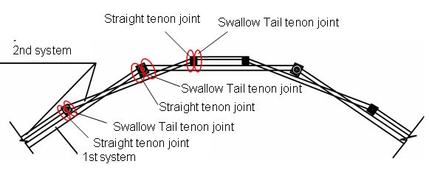

Fig.8: Mortise and tenon joint

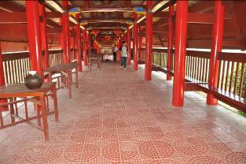 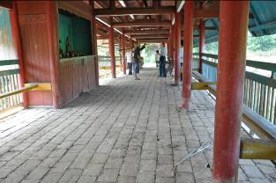 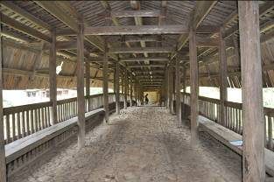 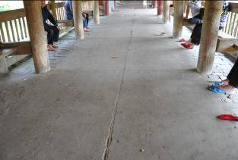

(a) Tiling (b) Brick (c) Stone (d) Concrete

Fig.9: Deck pavement types

**4.3 Spandrel Structure and deck system**

All the Min-zhe timber arch bridges are open spandrel arch bridges.

A bridge deck system consists of transverse beams, longitudinal beams and deck slabs. Generally, there are six deck transverse beams (three on each side), in which the one close to the abutment is supported by columns as shown in Fig.6. The transverse beam near the crown utilizes the transverse beam in the second arch ring system. Only the deck

transverse beams in quarter spans need spandrel supporting struts. The spandrel strut, also known as horse-leg in Chinese folk, consists of a pair of inclined members standing on the springing and two or three vertical or inclined members standing on quarter transverse beam in the second system.

Most bridges use plank as deck pavement. But other matreials are also used, such as tiling, brick, grait, stone and concrete, etc., as shown in Fig 9. The tiling is used during maintenance in modern times.

**5. Statistical analysis on main structural parameters**

**5.1 Definition of main structural parameter**

China timber arch bridges have some differences with other arch bridges. For example, the span and the rise of two systems are different; some bridges utilizing the natural rock as arch seats, rather than built the abutment, ect.. In this paper, according to the main structural parameter definitions in General code for design of highway bridges and culverts of China13), the length of the covering house is regarded as the length of the bridge, as shown in Fig.10(a,b), because the covering house is the most important feature of the Min-zhe timber arch bridge, and the length of the covering house is longer than the floor system. The width of covering house structure is regarded as the width of bridge, as shown in Fig. 10(b,c). The clear span and the clear rise of the first system are defined as the clear span and clear rise of the Min-zhe timber arch bridge, respectively, as shown in Fig.10(a).

**5.2 Length**

Most timber arch bridges are crossing very narrow rivers, streams or ditches in the ancient paths or in ancient villages. Therefore, most of them are single span bridges. There are only six multi-span timber arch bridges, 4 in Fujian Province and 2 in Zhejiang Province. Among these bridges, 3 bridges have three spans, 2 birdges have two spans and 1 has six spans. The major technical specifications of all the multi-span timber arch bridges are shown in Table 2.

The survey shows the lengths of the bridges are between 10m and 115m. The distribution of the length is shown in Fig.11. From Table 2, it can be found that the length of the multi-span bridges is between 35m to 115m, and four of them have a length over 60m. As for the other bridges with only one span, their lengths are not over 60m. Among them, 102 bridges have a span between 20m and 50m, accounting for 84.0% of the total, and the concentrated area of span distribution is 20m-40m, accounting for 67.2% of the total.

**5.3** **Span**

There are 122 single span timber arch bridges in China, whose detail is shown in Table.3. Number of bridges with the span length less than 10m is small. The main distribution range is from 20m to 30m, accounting for 42.6% of the total, near half of the total.

It is well-known that stone arch bridge has a long history and has achieved high prestige in China, such as the Chaw-Zhou Bridge completed in 605, which has a span length of 37.4m, the longest span in ancient China. It is also the first open spandrel arch bridge with segmental arch shape in the world. However, it is very surprise that the Ruanfeng Timber Bridge (Fig.12.) which is the longest span timber arch bridge in China, has a span length of 37.6m, exceeding the span of the Chaw-Zhou Bridge. This is not only shows the excellent bridge construction technology and the craft originality of the timber arch bridge in ancient China, but also explains their wide application in areas of southeast of Zhejiang Province and northeast of Fujian Province, which are also rich in stone and good at construction technology of the stone arch bridges in ancient China.



Length

Span

Rise

(a) Elevation view of China timber arch bridge

 

Width

Length

Width

(b) Plant view of covering house (c) Side view of covering house

Fig. 10: Diagram of structure of Min-zhe timber arch bridge

Table 2: Multi-span timber arch bridges

|  |  |  |  |  |  |  |
| --- | --- | --- | --- | --- | --- | --- |
| No. | Bridge Name | Place | Construction time | Type | Length(m) | Span(m) |
| 1 | Wan’an Bridge | Pingnan, Fujian | 1954 | Six spans | 96.6 | 13,16 |
| 2 | Suanglong bridge | Pingnan, Fujian | 2006 | Three spans | 66 | 19.9,18.9 |
| 3 | Qiancheng Bridge | Pingnan, Fujian | 1820 | Two spans | 62.7 | 27.5 |
| 4 | Helong Bridge | Minqing, Fujian | 1927 | Two spans | 53 | 12.5, 14.7 |
| 5 | Mengzhou Bridge | Qingyuan,Zhejiang | 2008 | Three spans | 115 | 29.6,23.4 |
| 6 | Jiajing Bridge | Qingyuan,Zhejiang | 2011 | Two spans | 35 | 15 |

Table 3: Span distribution of single span timber arch bridges

|  |  |  |  |  |
| --- | --- | --- | --- | --- |
| Span(m) | 0≤L<10 | 10≤L<20 | 20≤L<30 | 30≤L<40 |
| Quantity | 3 | 43 | 52 | 24 |
| Percent | 2.5% | 35.3% | 42.6% | 19.7% |

**5.4 Width**

Almost all of the timber arch bridges in China are served as footbridges. The bridges are not very wide, and there is no unified specification. The widths are mainly in the range of 4m-6m, mostly 4m-5m, accounting for 64.8%. The width distribution of the bridges is listed in Table 4.

Length(m)

20≤L<30

30≤L<40

40≤L<50

50≤L<60

L≥60

10≤L<20

Single span

Multi-spans

Amount

50

40

30

20

10

0

 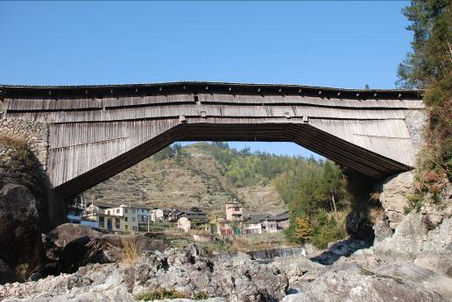

Fig. 11: Length of Min-zhe timber arch brige Fig. 12: The Ruanfeng Bridge

Table 4: Width distribution of the timber arch bridges

|  |  |  |  |  |
| --- | --- | --- | --- | --- |
| Width(m) | 3≤w<4 | 4≤w<5 | 5≤w<6 | 6≤w<7 |
| Quantity | 5 | 83 | 39 | 1 |
| Percent | 3.9% | 64.8% | 30.5% | 0.8% |

 

Fig.13: Rise-span ratio arrangement Fig14: Relationship between rise-span ratio and span



Fig.15: Relationship between diameter of arch ring members and span

**5.5 Rise-to-span ratio**

The rise-to-span ratio is an important parameter of arch bridges, which not only influences the internal forces, but also affects the structure type and construction method. An unreasonable ratio will break the harmony between a bridge and its surroundings. A smaller ratio causes larger axial forces, while a large ratio will weaken the lateral stability of the timber arch.

According to the measured values, the rise-to-span ratios of thirty-six China timber arch bridges are between 1/3 and 1/7, mostly between 1/5 and 1/7, as given in Fig.13. Only one exception is found to be 1/10. Fig. 14 shows that there is no obvious relationship between the rise-to-span ratio and the arch span in China timber arch bridges.

**5.6 Diameter of arch ring members**

Since the logs of the arch rings are the main resistant members of the bridge, their diameter were measured as an important structural parameter in the field survey.

According to the field survey, the diameters of arch ribs of two systems are between 18cm and 40cm, and the first system is always bigger than the second system. From the preliminary statistical results in Fig.15, there is a tendency that the longer the span of the bridge, the larger the diameter of the logs However, the relationship between the diameter and span is not so clear and definite.

**6. Conclusions**

The present suitation of China timber arch bridges is presented in this paper based on the field survey carried out by the authors, focusing on the structural characteristics of China timber arch bridges. The investigation shows:

1) There are 128 timber arch bridges in use today, and most of them were built in the Qing Dynasty (accounting for 53.9%).

2) Among 128 timber arch bridges, 122 of the are single-span bridges, only 6 of them are multi-span bridges. The length of the multi-span is between 35m to 115m, four of them have a length over 60m; while for the single-span bridges, their lengths are not over 60m. Among them, 102 bridges have a span between 20m and 50m, accounting for 84.0% of the total.

3) The spans are mainly in 10m-30m, and the concentrated area of span distribution is 20m-30m, accounting for 41.6%. The longest span is 37.6m. The width of bridges is in 4m-6m, mostly in 4m-5m. The rise-span ratios are from 1/3 to 1/7, usually in 1/5-1/7, and similar to the other arch bridges in China.

4) The diameters of arch ribs of two systems are between 18cm and 40cm, and the first system is always bigger than the second system. There is a tendency that the diameter of the logs becomes bigger with the increase of span length. However, the relationship between the diameter and span is not so clear and definite.

These results will provide references for further research.

China timber arch bridges achieve large span by weaving longitudinal and transverse straight logs in an ingenious way More research works, such as the parametric structural analysis of existing bridges, should be conducted in the future not only for protecting the China timbe arch briges, but also for inspiring the engineers to use the wood in the bridge engineering field.

**Acknowledgments**

The authors would like to express their sincere gratitude for science and technology development fund of Fuzhou university in China which provided the fund for this research work.

**References**

1. Yan Yang, Shozo Nakamura, Baochun Chen and Takafumi Nishikawa: Traditional construction technology of China timber arch bridges, Journal of Structural Engineering, Vol.58A, pp.777-784, 2012
2. Yan Yang, Baochun Chen and Jing Gao: Construction technology of the timber arch bridge in China, Proceedings of 2nd Chinese-Croatian Joint Colloquium on Long Span Arch Bridges, Fuzhou, China, pp.341-349, 2009.
3. Huangcheng Tang: Chinese Ancient Bridges, Beijing: Cultural Relics Press. Beijing, China, 1957 (in Chinese)
4. Yisheng Mao: History of Technique of Archaian Bridges in China, Beijing Press. Beijing, China, 1986 (in Chinese)
5. Huangcheng Tang: History of Science Technology in China, Bridge Volume. Science Press. Beijing, China, 2000. (in Chinese)
6. Huangcheng Tang: China Timber Arch Bridges, Beijing: Cultural Relics Press. Beijing, China, 2010 (in Chinese)
7. The Culture and Publication Board of Ningde city *edit*.: Archaeological investigation on Rainbow-beam type timber covered House Bridge in Ningde city of Fujian province, Science Press, Beijing, China, July, 2007. (in Chinese)
8. Yan Yang, Baochun Chen and Jing Gao: Timber Arch Bridges in China, Proceedings of the Fifth International Conference on Arch Bridge, Madeira, Portugal, pp.171-178, 2007.
9. Jie Liu and Weiping Shen: Lounge Bridges in Taishun.Shanghai People’s Fine Arts Press, Shanghai, China, 2005. (in Chinese)
10. The Propaganda Department of Qingyuan County *edit*.: The Capital of Covered House Bridges—Qingyuan．Xiling society of seal arts press, 2007. (in Chinese)
11. Yan Yang and Baochun Chen: Investigation of Timber Arch Bridge in Nanping area of Fujian Province, Proceedings of the Second Chinese Colloquium on Ancient Bridge,Fuzhou, 2009. (in Chinese)
12. Yan Yang and Baochun Chen: Management and preservation of timber arch bridges in Fujian, Proceedings of 3rd Chinese-Croatian Joint Colloquium on Long Span Arch Bridges, pp.395-402, 2011.
13. Ministry of communications of China: General code for design of highway bridges and culverts, JTG D60-2004, Communications press. Beijing, China, 2004. (in Chinese)

(2017.06.30 受付)